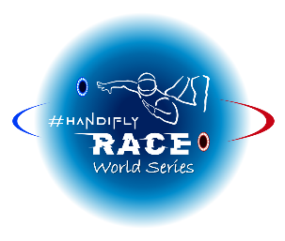

#### ANNEX 1

**DECLARATION and CONSENT FORM**

*Check and fill in the fields in yellow*

**1.1 IDENTITY**

**NAME, Surname** ___________________________________________________________________

**Date of birth**: ___ / ___ / _______ **Gender**: ▢ Male ▢ Female

**1.2 MEDICAL INFORMATION**

|  |  |
| --- | --- |
| **Eligible Impairment(s)** (tick one or more items) | **Name medical diagnosis relevant to impairment type** (tick or add) |
| ▢ Impaired Muscle Power | ▢ Spinal Cord Injury  ▢ Muscular Dystrophy  ▢ Spina Bifida  ▢ Poliomyelitis  ▢ Multiple Sclerosis  ▢ Other ____________________________________ |
| ▢ Impaired Passive Range of Movement | ▢ Arthrogryposis  ▢ Joint Contractures  ▢ Trauma  ▢ Other ____________________________________ |
| ▢ Limb Deficiency | ▢ Dysmelic  ▢ Traumatic Amputation  ▢ Bone Cancer  ▢ Other ____________________________________ |
| ▢ Leg Length Difference | ▢ Trauma  ▢ Dysmelic  ▢ Other ____________________________________ |
| ▢ Short Stature | ▢ Achondroplasia  ▢ Osteogenesis Imperfecta  ▢ Growth Hormone Dysfunction  ▢ Other ____________________________________ |
| ▢ Hypertonia    ▢ Ataxia    ▢ Athetosis | ▢ Cerebral Palsy  ▢ Traumatic brain injury  ▢ Multiple Sclerosis  ▢ Stroke  ▢ Other ____________________________________ |

|  |  |
| --- | --- |
| **Additional Eligible Impairment(s)** **- for NATIONAL** **CHAMPIONSHIPS ONLY** Athletes with these impairments are only eligible for the National Championships (when no other impairments occur) and will only be ranked in the National General Leaderboard, not in the International General Leaderboard of the Handifly Race World Series. | **Name medical diagnosis relevant to impairment type** (tick or add) |
| ▢ Hearing impairment | ▢ Reduced hearing power  ▢ Hearing loss  ▢ Other ____________________________________ |
| ▢ Intellectual disability | ▢ Down syndrome / trisomy 21  ▢ Other ____________________________________ |
| ▢ Any other disability (not stated above) | ▢ Please specify ________________________________________________________________________________________________________________________________________________________________ |

**1.3 MEDICAL HISTORY**

**Flyer’s condition**: ▢ Stable ▢ Progressive ▢ Fluctuating ▢ Permanent

**Year of onset**: _______ ▢ Congenital

**Past treatments**:

__________________________________________________________________________________________________________________________________________________________________________

**Current and/or future treatments**:

__________________________________________________________________________________________________________________________________________________________________________

**In case of spinal cord injury, indicate the number of the vertebrae(s) affected and accurately describe the motor and sensory consequences of these lesions**:

___________________________________________________________________________________________________________________________________________________________________________________________________________________________________________________________________________________________________________________________________________________________________________________________________________________________________________________________________________________________________________________________________________________________________________________________________________________

**Additional details on medical diagnosis (mandatory)**:

___________________________________________________________________________________________________________________________________________________________________________________________________________________________________________________________________________________________________________________________________________________________________________________________________________________________________________________________________________________________________________________________________________________________________________________________________________________

**Functional Self-Analysis in Flight of Main Aerodynamic Surfaces (using the diagram, fill in the yellow boxes below)**:

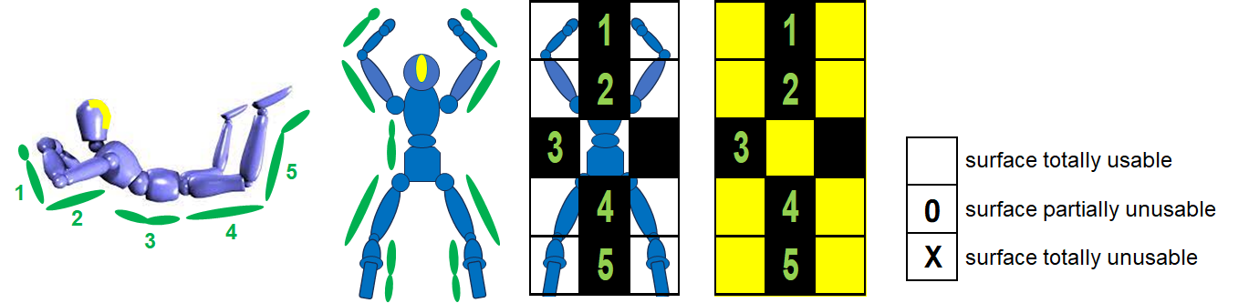

**Possible additional comment**:

___________________________________________________________________________________________________________________________________________________________________________________________________________________________________________________________________________________________________________________________________________________________________________________________________________________________________________________________________________________________________________________________________________________________________________________________________________________

**1.4 EVALUATION CONSENT**

1. I agree to undergo the Athlete Evaluation detailed in the Handifly Race Competition Rules and the Handifly Race Classification Rules carried out by a Classification Board designated by the ISC Permanent Classification Board of the ISC Skydiving for Disabled Committee. I understand that this evaluation may require me to participate in wind tunnel Flights and activities which may include me being observed whilst competing. I understand that there is a risk of injury in participating in Flights and activities. I confirm that I am healthy enough to participate in Athlete Evaluation.

2. I understand that I have to comply with the Athlete Evaluation’s requests made by the Handifly Race Classification Rules. This includes providing sufficient documentation so as to allow the Classification Board to determine whether I comply with the eligibility requirements for Handifly Race. I understand that if I fail to comply with any such request then Athlete Evaluation may be suspended without a Compensation Coefficient being assigned to me.

3. I understand that the Athlete Evaluation requires me to give my best effort, and that any intentional misrepresentation of my skills, abilities or the degree of my impairment may result in me facing immediate exclusion.

4. I understand that the Athlete Evaluation is an assessment process and I agree to abide by the judgment of the Classification Board. If I do not agree with the decision of the Classification Board, I understand that I still have the possibility to submit a protest to the Classification Board’s representative on the competition site before the first non-scored Flight.

5. I agree to be videotaped and photographed during the Athlete Evaluation and that this may include my activity on and off the wind tunnel during the competition.

6. I agree and consent to the ISC Permanent Classification Board processing my personal data in any format, including my full name, e-mail address, nationality, date of birth, gender, Compensation Coefficient and relevant medical information.

7. I agree and consent to my full name, e-mail address, nationality, profile (as I filled it in when I submitted my application) and Compensation Coefficient published by the ISC Permanent Classification Board and shared with third parties.

▢ I wish to assist the ISC Permanent Classification Board in developing the classification system and therefore allow my data collected during Athlete Evaluation and video material recorded during training and competition to be used for research and educational purposes by the ISC Permanent Classification Board. I understand that I may withdraw this consent at any time.

Date ___ / ___ / ______

Signature of the applicant: _______________________