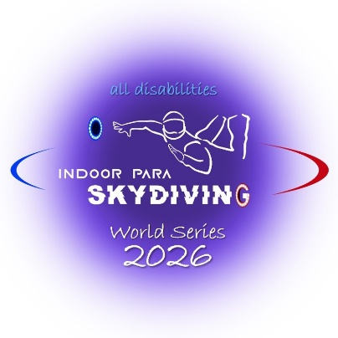
DECLARATION AND CONSENT FORM

INDOOR PARA SKYDIVING WORLD SERIES
ATHLETE EVALUATION, MEDICAL DIAGNOSTIC, AND AGREEMENT FORM

Family Name: |  | Date of Birth:
First Name: |  | Gender: | - Female
Country |  |  | - Male
Athlete Self-Assessment Table
Please use the table below (on the left) to indicate the impact/effect of any Impairments on the athlete’s Main Aerodynamic Surfaces (areas numbered 1 to 5) during flight. Use the following notation: [blank] – No activity limitation; 0 – Limited mobility; X – Surface non-functional.
The reference diagram on the right indicates the surfaces analyzed during athlete evaluation for the assessment of the impact/effect of any Impairments. The numbered areas are (1) hand-forearm, (2) arm, (3) torso, (4) leg, and (5) tibia-foot, shown in green on the reference diagram.
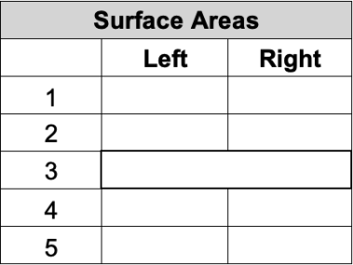  [blank] [blank] [blank] [blank]  [blank] [blank] [blank] [blank] [blank] | 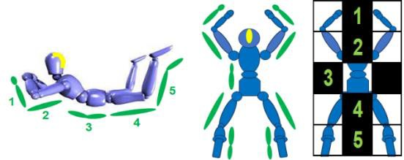

Medical Information
Athlete’s Medical Diagnosis (Health Condition):
Include description of body part(s) affected and limitations:
Medical Condition is: Permanent Stable Progressive Fluctuating
Year of Onset: Congenital (birth)

 |  |  | Primary Impairment/s arising from the Medical Diagnosis (Health Condition):
 |  |  | Impairment Type | Relevant Medical Diagnosis
 |  |  | ▢ Impaired Muscle Power | ▢ Spinal Cord Injury
 |  |  |  | ▢ Muscular Dystrophy
 |  |  |  | ▢ Spina Bifida
 |  |  |  | ▢ Poliomyelitis
 |  |  |  | ▢ Multiple Sclerosis
 |  |  |  | ▢ Other:
 |  |  | ▢ Impaired Passive Range of Movement | ▢ Arthrogryposis
 |  |  |  | ▢ Joint Contractures
 |  |  |  | ▢ Trauma
 |  |  |  | ▢ Other:
 |  |  | ▢ Limb Deficiency | ▢ Dysmelic
 |  |  |  | ▢ Traumatic Amputation
 |  |  |  | ▢ Bone Cancer
 |  |  |  | ▢ Other:
 |  |  | ▢ Leg Length Difference | ▢ Trauma
 |  |  |  | ▢ Dysmelic
 |  |  |  | ▢ Other:
 |  |  | ▢ Short Stature | ▢ Achondroplasia
 |  |  |  | ▢ Osteogenesis Imperfecta
 |  |  |  | ▢ Growth Hormone Dysfunction
 |  |  |  | ▢ Other:
 |  |  | ▢ Hypertonia | ▢ Cerebral Palsy
 |  |  | ▢ Ataxia | ▢ Traumatic Brain Injury
 |  |  | ▢ Athetosis | ▢ Multiple Sclerosis
 |  |  |  | ▢ Stroke
 |  |  |  | ▢ Other:
▢ Vision Impairment |  |  |  | ▢ Retinas Pigmentosa
 |  |  |  | ▢ Diabetic Retinopathy
 |  |  |  | ▢ Other:
▢ Intellectual Impairment |  |  |  | ▢ Down Syndrome
 |  |  |  | ▢ Autism
 |  |  |  | ▢ Other:
▢ Hearing Impairment |  |  |  | ▢ Profound Loss
 |  |  |  | ▢ Other:
 | ▢ Hypotonia |  |  |  | ▢ Prader-Willi Syndrome
 |  |  |  |  | ▢ Muscular Dystrophy
 |  |  |  |  | ▢ Other:
 | ▢ Hypermobility |  |  |  | ▢ Ehlers-Danlos Syndrome
 |  |  |  |  | ▢ Other:
 | ▢ Other Disabilities |  |  |  | ▢ Other:
Medical History
 |  | Past treatments:
 |  | Current and/or future treatments:
 |  | For spinal cord injuries, please specify the affected vertebrae(s) and describe the resulting motor and sensory consequences.
 |  | Please provide additional details regarding the medical diagnosis (required):
Diagnostic Evidence to be possibly Attached:
Indoor Para Skydiving reserves the right to request additional diagnostic evidence as outlined in the IPS Competition Rules and Classification Code, including, but not limited to Medical Diagnostic Report and Physical Examination results (e.g., ASIA scale for athletes with spinal cord injury, Ashworth scale for athletes with cerebral palsy, X-rays for athletes with dysmelia, photo for athletes with amputation) or report(s) from additional diagnostic testing (for example, EMG, MRI, CT, X-ray).
 |  | Regular Medication – List dosage and reason:
 |  | Additional Comments (Optional):
 |  | I CONFIRM THAT THE ABOVE INFORMATION IS ACCURATE AND CORRECT.
 |  | Signature: Date:

1.1 ATHLETE’S AGREEMENT DECLARATION AND CONSENT

- I wish and consent to undergo the Athlete Evaluation as outlined in the Indoor Para Skydiving Competition Rules and Classification Code, conducted by the Classification Board appointed by the Fédération Française de Parachutisme. I understand that this evaluation may involve participation in wind tunnel flights and activities, including being observed during competition. I acknowledge the inherent risk of injury in participating in these flights and activities and confirm that I am physically fit to participate in the Athlete Evaluation.
- I understand that I must comply with the requests made during the Athlete Evaluation as outlined in the Indoor Para Skydiving Classification Rules. This includes providing the necessary documentation to enable the Classification Board to assess the existence of an underlying health condition and an Eligible Impairment, determining my athlete's eligibility to compete in Indoor Para Skydiving. I acknowledge that if I fail to submit the required documentation or do not fully comply with the requested evaluation processes, my Athlete Evaluation may be suspended, and as a result, I will be deemed Not Eligible to participate.
- I understand that the Athlete Evaluation requires me to provide an honest and accurate representation of my skills, abilities, and the extent of any physical impairments. I acknowledge that any intentional misrepresentation or dishonesty in this process may lead to my immediate disqualification from the evaluation and exclusion from the competition.
- I understand that the Athlete Evaluation is an assessment process, and I agree to abide by the decision of the Classification Board. In the event of any disputes, I acknowledge that I have the right to submit a protest before the beginning of the non-scored flights of the competition. The protest must be submitted in writing, along with the necessary supporting documentation, directly to the Classification Board’s representatives or the Event Judge. In such case, the revised decision is final and cannot be challenged further.
- I agree to be videotaped and photographed during the Athlete Evaluation, which may include my activities both inside and outside the wind tunnel, before and during the competition. I understand that this footage and imagery may be used for evaluation, documentation, and any related purposes as outlined in the competition rules.
- I hereby consent to the Classification Board of the Fédération Française de Parachutisme processing my personal data, including my full name, email address, nationality, date of birth, gender, Compensation Coefficient, and relevant medical information, in any format as required.
- My personal data, including relevant medical information, Athlete Evaluation, and Compensation Coefficient, will be collected, stored, and used by the Classification Board. This may include transferring or storing data on different servers. The Classification Board, which may include members and organizations located outside the European Union and not recognized by the European Commission as providing adequate data protection, will use this data solely for purposes related to athlete evaluation and supporting my participation in Indoor Para Skydiving competitions.
- I agree and consent to my full name, gender, year of birth, country, and Compensation Coefficient being published by the Classification Board and shared with competition organizers, and relevant third parties, including, but not limited to, the Fédération Française de Parachutisme, the Fédération Aéronautique Internationale (FAI) and the International Skydiving Commission (ISC).

I wish and consent to contribute to the improvement of Indoor Para Skydiving by assisting the Classification Board of the Fédération Française de Parachutisme in refining the classification system. Therefore, I consent to the use of any data collected during the Athlete Evaluation, as well as any video material recorded during training and competition, for research and educational purposes by the Classification Board of the Fédération Française de Parachutisme. I understand that I can withdraw this consent at any time.
▢

Athlete’s Name:

Athlete’s signature: Date:

Legal Guardian or Representative’s Name (if required):
Legal Guardian or Representative’s Signature: Date:

